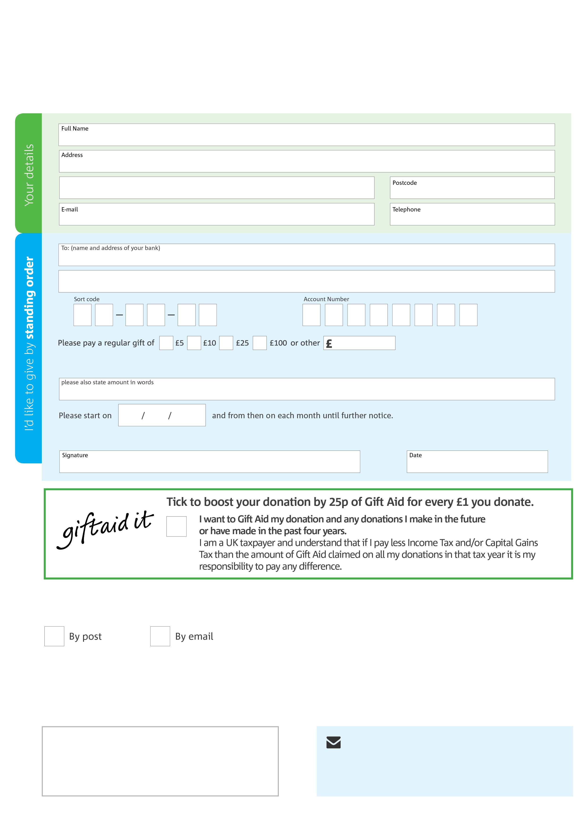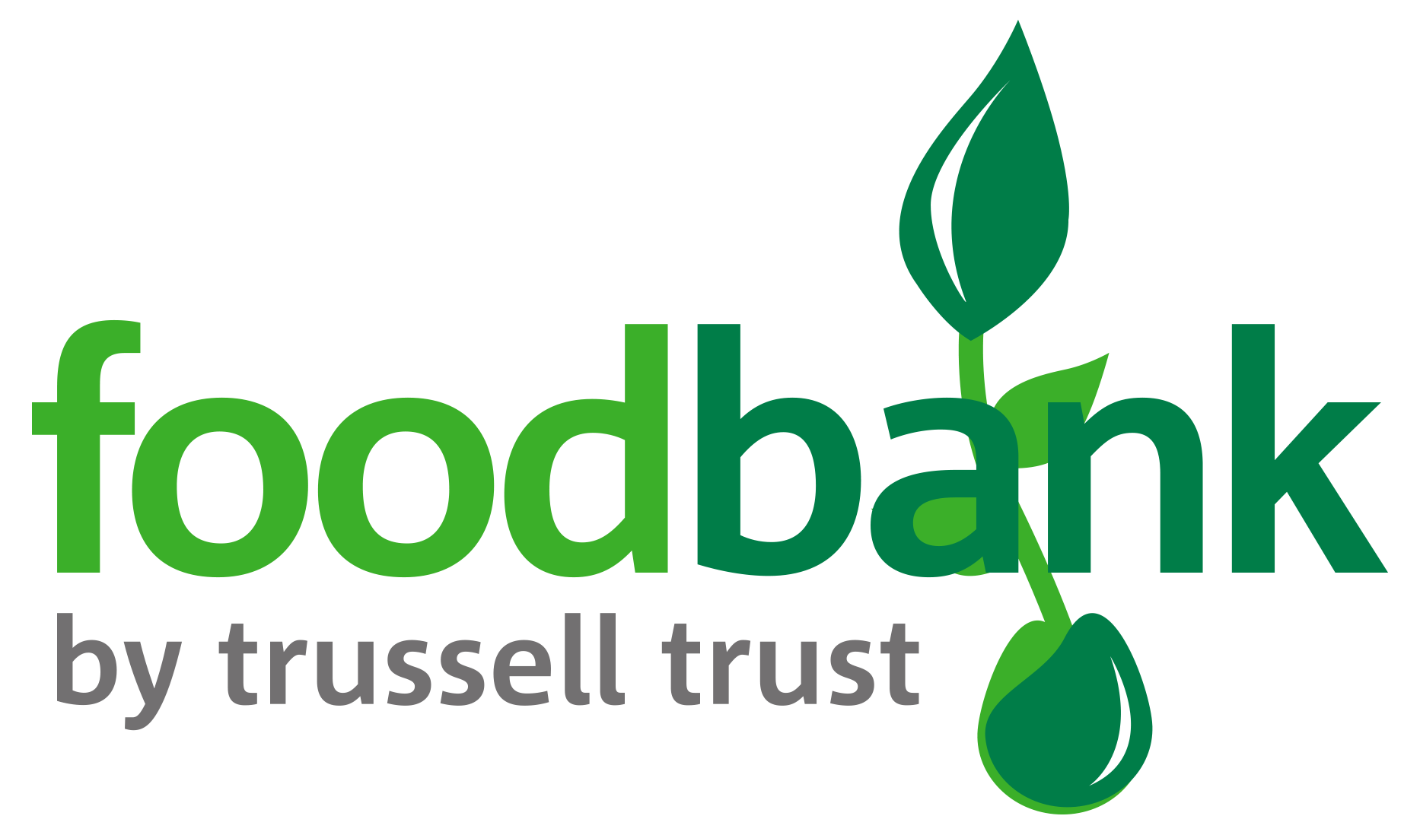­

**Please send your completed form to your bank and to:**

Mr S. Singh

Treasurer, Caterham Foodbank

4 Beechwood Road

Caterham. CR3 6NA

**Data protection**

Caterham Foodbank is committed to protecting your privacy and will process your personal data in accordance with the Data Protection Act 1998. Caterham Foodbank collects information to keep in touch with you and supply you with information relating to our work. Caterham Foodbank will never sell or pass your details to anyone who isn’t directly working on our behalf.

**We would love to keep in touch with you so we can update you on our work. You can change your preferences any time by contacting us on 07523983122 or emailing us at info@caterham.foodbank.org.uk**

**Please tick here if you would be happy to receive communications from us:**

**Caterham Foodbank’s bank details:**

CAF Bank

Sort code : 405240

Account number : 00024411

This cancels any previous standing order instructions to Caterham Foodbank

To Caterham Foodbank each month,

www.caterham.foodbank.org.uk

Reg. Charity No: 1155330 | Reg. in England & Wales