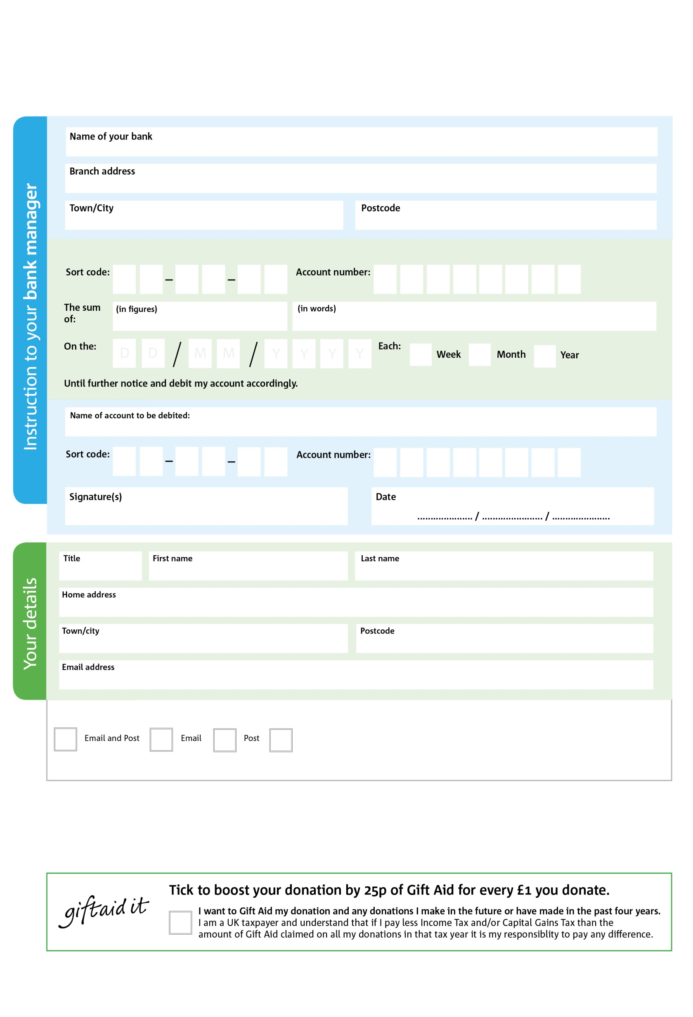

Reg. Charity No: 1155330 | Reg. in England & Wales

1

V

4

V

4

V

1

V

2

V

0

V

0

V

0

V

5

0

4

2

0

4

POSTAL ADDRESS: Caterham Foodbank, 4 Beechwood Road, Caterham, Surrey. CR3 6NA

**Please pass this form onto the foodbank, using the foodbank’s address at the bottom, who will save a copy for their records.   
They will then send it onto your named bank or building society.**

We would love to keep you up to date with information about Caterham Foodbank. Please tick your preference:

You can change your preferences any time by contacting us on 07523983122 or emailing us at info@caterham.foodbank.org.uk

I do not wish to receive future communications from Caterham Foodbank

Please pay Caterham Foodbank,

**Data protection**

*'Caterham Foodbank is committed to protecting your privacy and will process your personal data in accordance with current Data Protection legislation. Caterham Foodbank collects information to keep in touch with you and supply you with information relating to our work. To unsubscribe from our newsletter, send a message to the email address above with the word unsubscribe in the subject line. A full data privacy statement for financial donors is available from the foodbank on request.’*

**Standing Order Mandate**

**www.caterham.foodbank.org.uk**

You can change your preferences any time by contacting us on XXXXXXXXXXX or emailing us at XXXX@XXXXXXXXXX.foodbank.org.uk

I do not wish to receive future communications from XXXXXX Foodbank